Demandware Implementation Guide
Merchant Services
5/12/2014
Version 2.0





Table of Contents
Summary 3
Component Overview 4
Functional Overview 4
Limitations, Constraints 4
Compatibility 4
Privacy, Payment 4
Implementation Setup 5
Setup 5
Configuration 5
Step 1 - Site Import 6
Step 2 - Kount Site Preferences 9
Configuration of UDF Fields (This is an optional portion of the integration.) 10
ERROR Notification System 12
Step 3 – Certificate & Key File Import 13
Step 4 – Configure Event Notification System 15
Step 5 - Assign Cartridge to Site 16
Custom Coding Requirements 17
External Interfaces 20
Modifying UDF map 20
Appendix A: Manual Integration Steps 21
Appendix B: Test Cases 27
Verifying the Functionality of the Cartridge: Test Cases 27
Appendix C: Demandware Order Workflow 36
Kount Review/Escalate 36
Kount Approved 37
Kount Decline 38
Appendix C: Certificate Exportation 40
Firefox 40
Certificate Request: 40
Certificate Export: 41
IE 9 44
Prerequisites 44
Certificate Request: 46
Certificate Export: 47

Summary
Kount is a leading innovator of solutions for fraud and risk management. Kount's “decision engine” platform is ideal for managing fraud in online/telephone channels that process payments and onboard new customers. Kount is committed to offering an end-to-end, single-source solution focused on speed, simplicity and ease of use...with a no-compromise approach to providing real-time accuracy in results.
The Kount Demandware cartridge will provide rapid integration for Demandware implementations. The Kount cartridge is a self-contained cartridge that can easily integrate into any project. This cartridge can be configured in the Business Manager and contains all elements necessary to perform a successful best practices implementation of Kount.
The Kount Demandware cartridge can be obtained from:
- Demandware Secured LINK Marketplace Website
- Request from your Kount Technical Account Manager

Requirements for Kount Demandware cartridge:
- All steps from UX Studio Installation & Sandbox Setup Guide (from Demandware) have been completed
- Open SSL is installed locally with no additional libraries installed
- A Demandware Development Resource: The Integration and installation process includes deployment of a generic cartridge and modification of storefront code & pipelines.

Component Overview

Functional Overview
Kount cartridge provides integration for such functionality
- RIS(Risk Inquiry System) and Data collector implementation in checkout process; Support current payment types:
  - Credit card type
  - PayPal
  - Gift Certificate
- ENS(Event Notification System) callback.

Limitations, Constraints
- No AVS or CVV information has been passed.
- Only listed payment methods will be sent to Kount

Compatibility
Cartridge designed for Demandware API version 14.8.
Compatibility Mode: 10.6

Privacy, Payment
Kount supports different payment types and depends on chosen by the customer payment type (payment tokens are required). If chosen payment method not supported by Kount, then a value of NONE should be passed.
The integration uses customer profile data, and transfers it to Kount. Hashed credit card data is sent to Kount system. The following credit card data is sent:
- Masked credit card number (Salted Irreversible Hash; PCI Level 1 Compliant)
- Card holder name
- Credit card type

Cartridge Stability
Kount cartridge has increased its stability. Cartridge will not interfere with default checkout flow of a site in case an error occurs in Kount cartridge or Kount service. Errors from Kount will be logged into separate log file. Log file name convention: custom-Kount-blade0-4-appserver-<date stamp>.log

Implementation Setup

Setup
The int_kount cartridge is required for the integration. Please obtain the cartridge from your Kount Technical Account Manager. The cartridge will also be available to all Demandware merchants via their secured LINK Marketplace website.
Cartridge name | int_kount
Pipelines | K.xml  K_ENS.xml
Scripts | kount/IPFilter.ds  kount/KountUtils.ds  kount/LibKount.ds  kount/PostRiskInqueryService.ds  kount/SelectEventNodeName.ds  kount/UpdateCustomAttribute.ds  kount/UpdateOrder.ds  kount/CheckProductInventory.ds  kount/UpdateOrderExportStatus.ds
CSS | kount.css
Templates | kount/confirmationENS.isml  kount/iframe.isml  kount/logo.isml  mail/risk_change.isml  mail/errornotification.isml
Static resources | resources/kount.properties  resources/error.properties
Metadata | kount_metadata.xml

Configuration
The integration requires 5 configuration steps:
- Use Site Import to Create Custom System Object Definitions & Setting Kount Site Preferences for each site
- Certificate Conversion and Certificate & Key file Import to Business Manager
- Configuring the Event Notification Service
- Assign the Cartridge to a Site
- Modify Storefront Code and Pipelines

Note: Manual integration instructions for step 1 can be found in Appendix A.

Step 1 - Site Import
Use the kount_metadata.xml file to create the custom System Object definitions and configure the Kount Site Preferences.
    - Login into Demandware Business Manager.
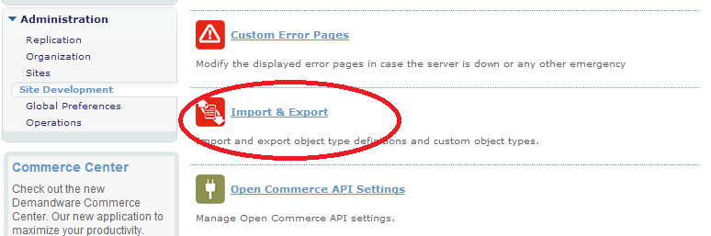
    - Select the Administration section -> Site Development -> Import & Export

    - Select the Upload button to upload the kount_metadata.xml file.
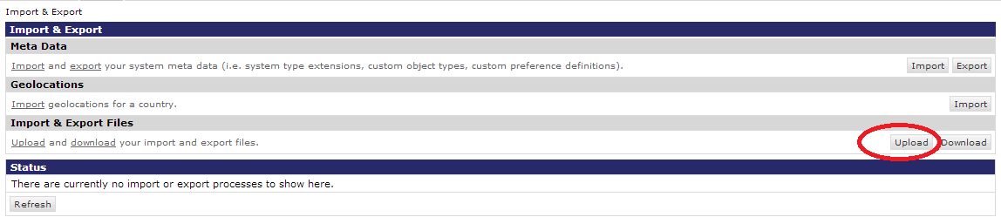
    - Select the Choose File button and navigate to the kount_metadata.xml file. Select the Upload button.
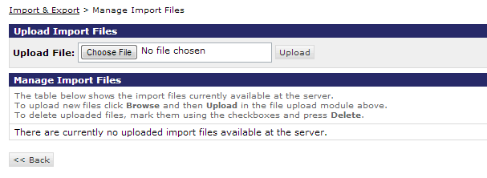
Notice that now the kount_metadata.xml file is listed within the Manage Import Files page.
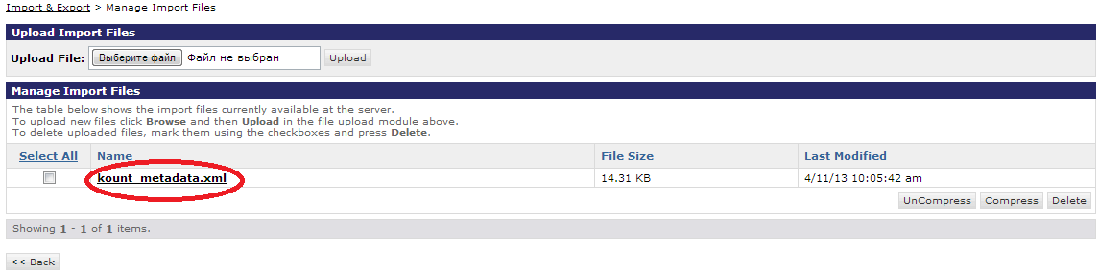
    - Navigate back to the Import & Export page.
    - Select the Import button. 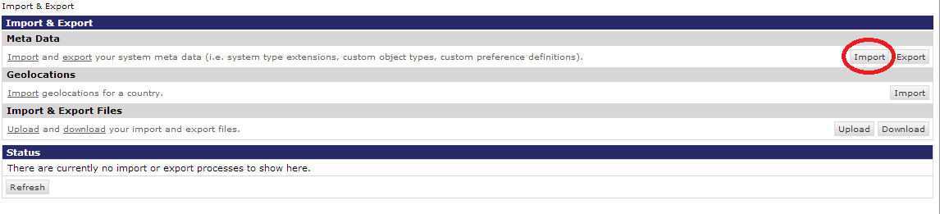

    - Select the radio button next to the kount_metadata.xml file and choose the Next button. An XML Validation will run.
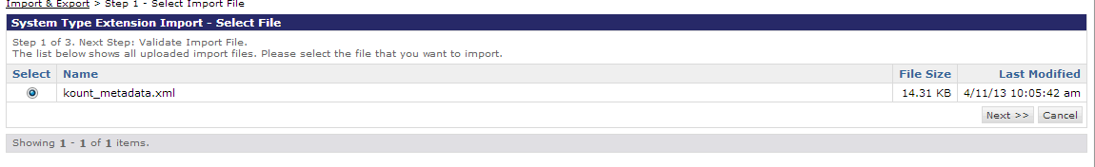
    - Select the Import button.
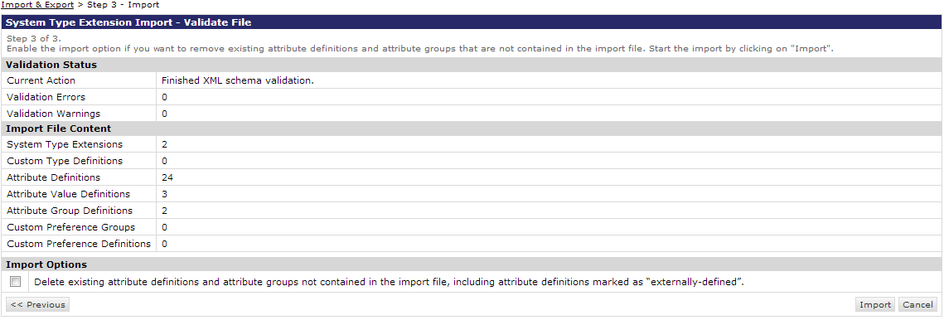
After the import has finished a “Success” status will display.
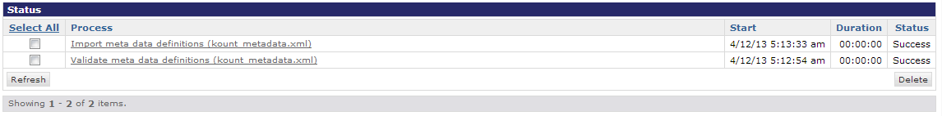
If a Status of Success does not display, then check the Demandware Sandbox Setup (Site Genesis) and complete steps 6-8 again.
NOTE: The Demandware Sandbox will need to be rebooted (from Demandware) before the site changes will take effect. Sandboxes are rebooted automatically every night.

Step 2 - Kount Site Preferences
The Kount Site Preferences will need to be filled into the fields within this page. The script file will display the default values to the right of the screen, but does not populate the fields automatically. Verify the Site Preferences by navigating to Site -> Site Preferences -> Custom Preferences. Select Kount. The Custom Site Preferences page will display. All Sandbox Boarding information needed for this page will be provided by your Kount Technical Account Manager.
Important: The URL’s provided for Sandbox Boarding will not be used in the Production environment. Production Boarding information will be provided to the Merchant following their certification, authorizing the Merchant to begin sending production traffic. Contact your Technical Account Manager if you have any questions or concerns.
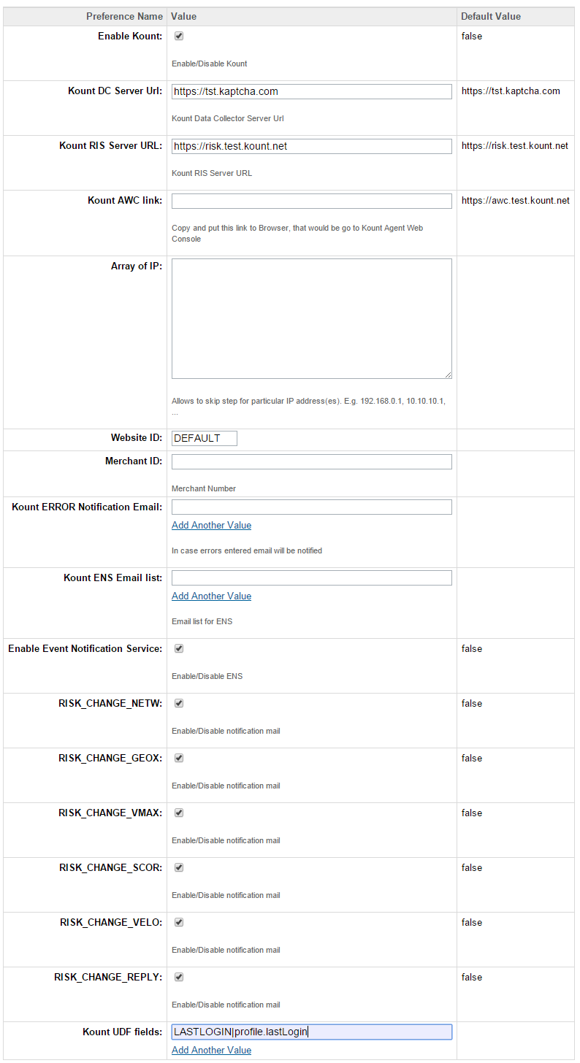

Configuration of UDF Fields
(This is an optional portion of the integration.)
Kount provides a way for merchants to include additional information related to their business that may not be a standard field in Kount by creating user defined fields. Those fields can be setup in Business Manager Site Preference section.
User defined fields should be first setup in Kount admin panel

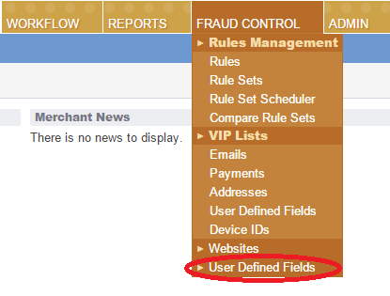
On opened page press Add UDF button. On opened popup UDF could be defined. UDF field has type Number by default. In order to change the type, it is necessary to select appropriate value using the Type dropdown.
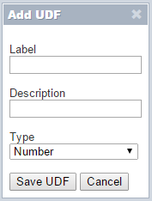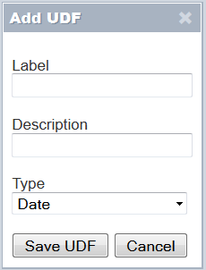
After defined field result could be seen
To pass information into UDF fields Business Manager Site Preferences in Kount group should be setup too. Find preferences Kount UDF fields, it should be setup in proprietary manner using such pattern.
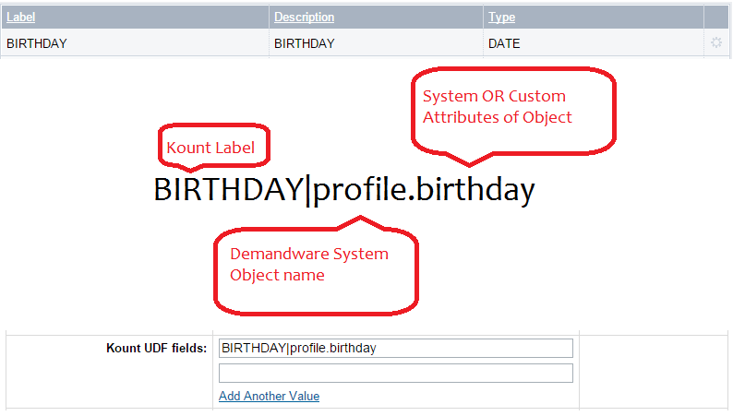
By default there are 4 accessible DW object:
Object Name | Label Name | Example Use
Order | order | Date|order.date
Shipping Address | shippingaddress | State|shippingaddress.state
Billing Address | billingaddress | City|billingaddress.city
*Customer Profile | profile | DOB|profile.dob

Customer Profile: Information will be exported in case order was placed by registered customer.
List representing System Objects and System/Custom attributes could be found in Business Manager –> Administration
–> Site Development –>System Object Definitions.
Types of data which are supported for passing to Kount:
DW Data Type | Kount UDF Type
String | Alpha-Numeric
Date | Date
Number | Number
The Amount UDF Type is not supported in Demandware at this time.
Notes: To support other Demandware objects additional development should be done, see section - Modifying UDF map

ERROR Notification System
The Kount cartridge has been extended with improved logging system. In case unexpected error appears in Kount service this error will be logged in a separate log file on Demandware instance and email will be sent to the list of emails which were setup in Site Preferences
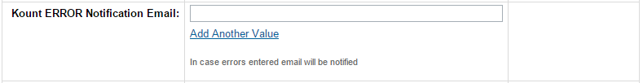

Example of the email body for a Notification Email:
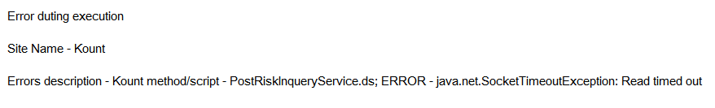

Step 3 – Certificate & Key File Import
A RIS Certificate must be created, converted and imported into the Demandware Business Manager. See Appendix D for Certificate Export instructions.
Note: The following instructions assume that:
- A X.509 Self Signed certificate has been created from the Agent Web Console.
- OpenSSL has been installed with no additional libraries
- The original .p12 or .pfx file reside within the OpenSSL directory (no friendly pathing).
- Convert the original .p12 to a .pem format certificate using the following command line instruction from OpenSSL.
Enter the password used to create the file during the initial export of the certificate from the browser. A “MAC verified OK” message will display if the password was entered correctly.
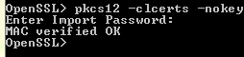
- To import the converted certificate and original .p12 or .pfx private key file into the Business Manager navigate to Administration -> Operations -> Private Keys and Certificates.
- Select the Import button (as shown below).
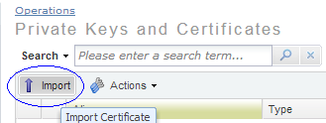
- Browse to the location of the converted pem certificate file. Enter https://risk.test.kount.net (for use within the Test environment) in the Alias field. Select the Import button.
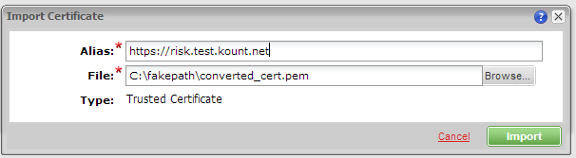

- Select the Import button again.
- Browse to the original .p12 or .pfx file that was exported from the browser.
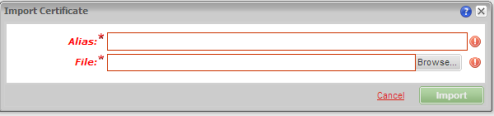
As soon as you open the .p12 or .pfx file the dialog box will change. Enter ris_private_key within the Alias field. Enter the password that was used to create the certificate. Enter https://risk.test.kount.net (for use within the Test environment) in the Host Names field and choose the ADD button similar to the image below. Select the Import button.
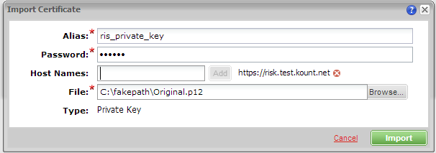
The Private Keys and Certificates will display below with grayed out dates and import confirmation until the Demandware Sandbox is rebooted. The Demandware Sandbox automatically reboots every night.
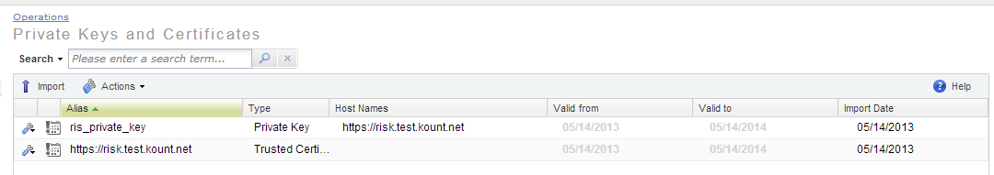
Below is how the Private Key and Certificate will display after the Demandware Sandbox has been rebooted.
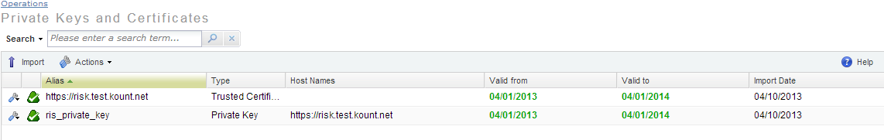

Step 4 – Configure Event Notification System
Important: New Certificate and Key Files will need to be created for use within the Production environment. The URL’s provided for Sandbox Boarding will not be used in the Production environment. Production Boarding information will be provided to the Merchant following their certification,
authorizing the Merchant to begin sending production traffic.
Contact your Technical Account Manager if you have any questions or concerns.
To configure the Event Notification Service (ENS) a Merchant URL will need to be set within Demandware and within the Kount Agent Web Console. All Event Notifications will be sent to this URL as an XML post.
- Identify the Merchant URL. Use the example below to help discover your unique URL.
Example of Event Notification System URL:
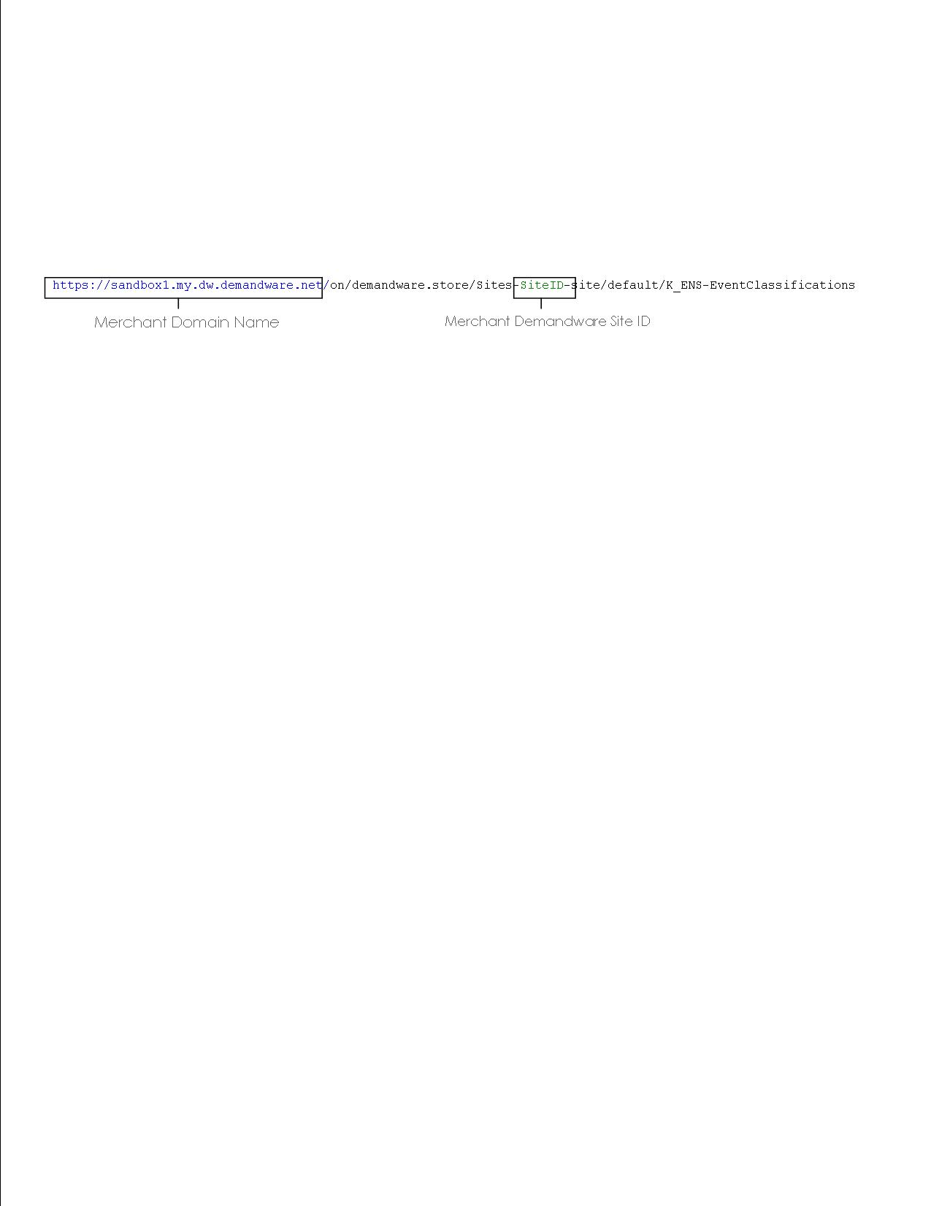
The rest of the URL is primarily static values. The “default” value may be different if the merchant is using another language aside from English.
- Set the ENS URL within Kount, navigate to the Fraud Control tab -> Websites. Select the GEAR, (circled in the image below).
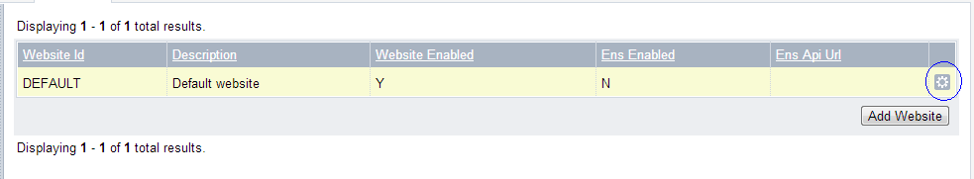
- The Edit Row dialog will display. Choose the ENS Enabled Radio button. Enter the ENS URL (that is unique to your merchant account) within the Merchant ENS URL field. Select the Update Website button.
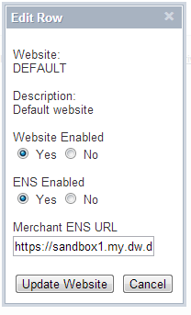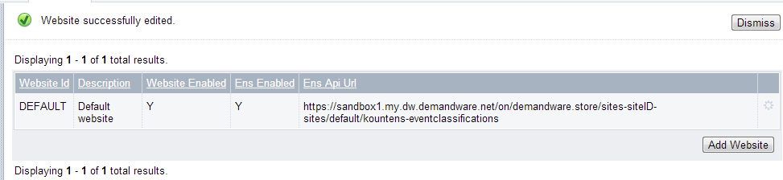
Notice the confirmation in the upper left stating the Website was successfully edited.

Step 5 - Assign Cartridge to Site
The Cartridge will need to be assigned to the Merchant’s website & Business Manager.
- Navigate to Administration -> Sites -> Manage Sites. Select the appropriate site(s).
- Add the cartridge into the cartridge list for each site where Kount is needed by including the following prefix within the cartridge field:
int_kount:
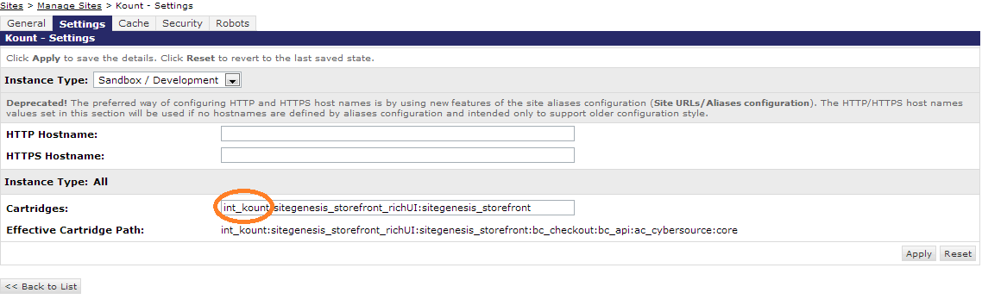
- Select the Apply button.
- Navigate to Administration -> Sites -> Manage Sites. Select Manage the Business Manager site.

- Add the cartridge into the cartridge list for the Business Manager by including the following prefix within the cartridge field:

int_kount:
- Select the Apply button.
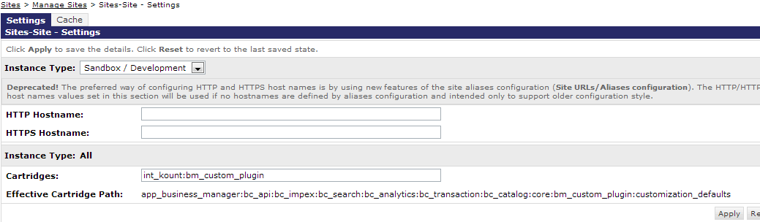

Custom Coding Requirements
There are portions of the Kount cartridge implementation that require additions to the internal coding & pipelines of the Demandware storefront code. Please consult with your Demandware development resources to complete this portion of the Kount integration.
            - Navigate in Eclipse to your storefront cartridge. Other editors maybe used, the following steps are documented for use with Eclipse. Please reference the Demandware Test Drive documentation for further information.
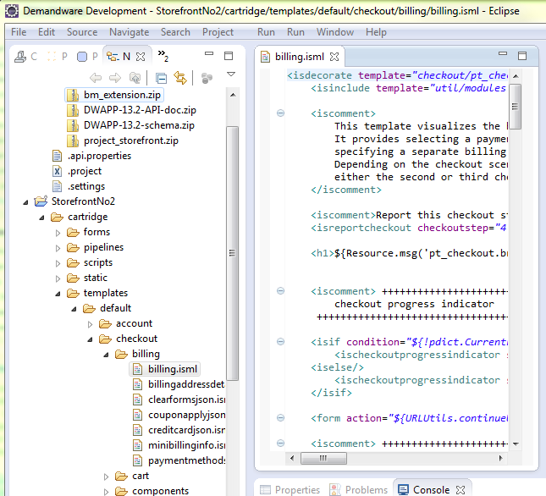
            - Open the Template folder, navigate to checkout/billing/billing.isml (as shown above) and find the billing address line that displayed in the screenshot below.
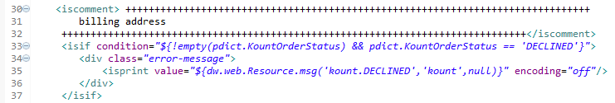
            - Insert these additional lines of code (as shown in the example) and save the file.
<isif condition="${!empty(pdict.KountOrderStatus) && pdict.KountOrderStatus == 'DECLINED'}">
<div class="error-message">
<isprint value="${dw.web.Resource.msg('kount.DECLINED','kount',null)}" encoding="off"/> </div>
</isif>

            - Remaining within the Template folder, navigate to checkout/billing/paymentmethods.isml and find line displayed in the screenshot below. (Tip: Turn on Line No.’s to locate.)
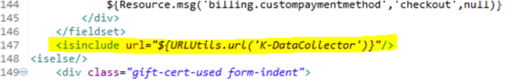
            - Insert the additional line of code (as shown in the example) and save the file.
<isinclude url="${URLUtils.url('K-DataCollector')}"/>
            - Open the Pipeline folder, navigate to COPlaceOrder.xml (Tip: Use Ctrl+Shift+R to search if you are using Eclipse) and insert Call Node, insert some changes:
- To create the Risk Inquiry Service(RIS) post we must insert K-PostRIS Call Node
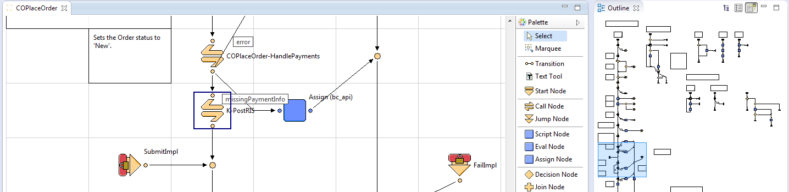
- For GVM for order in case APPROVED request to Kount insert K-CheckKountStatus call node
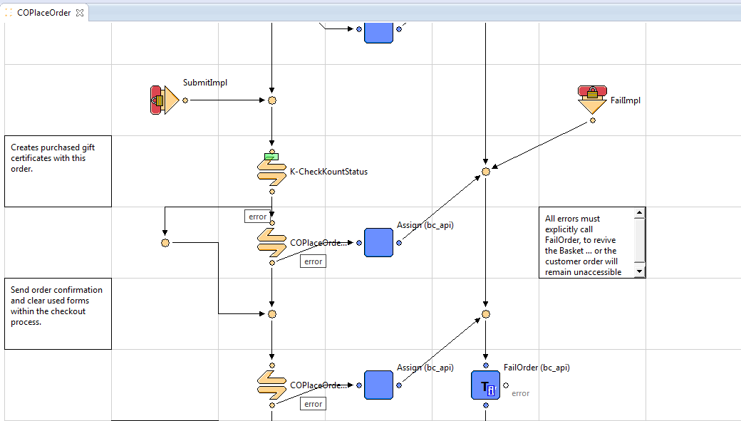
- For update ExportOrderStatus, update script SetOrderStatus.ds with code below and setup input parameter KountOrderStatus(see image below):

SetOrderStatus.ds :
/**
* Set the order export status to EXPORT_STATUS_READY
*
* @input Order : dw.order.Order The order.
* @input KountOrderStatus : String
*/
importPackage( dw.order );

function execute( pdict : PipelineDictionary ) : Number
{
// read pipeline dictionary input parameter
var order : Order = pdict.Order;

// get Kount order status result
var kountOrderStatus : String = pdict.KountOrderStatus;

// Special case if Kount order status is HOLD
if( !empty( kountOrderStatus ) && kountOrderStatus == 'APPROVED' && order.getExportStatus().getDisplayValue() != 'EXPORTED' ) {
order.setExportStatus(Order.EXPORT_STATUS_READY);
} else if( !empty( kountOrderStatus ) && ( kountOrderStatus == 'DECLINED' || kountOrderStatus == 'HOLD' ) ) {
order.setExportStatus(Order.EXPORT_STATUS_NOTEXPORTED);
} else {
// set the export status to EXPORT_STATUS_READY
order.setExportStatus(Order.EXPORT_STATUS_READY);
}

return PIPELET_NEXT;
}

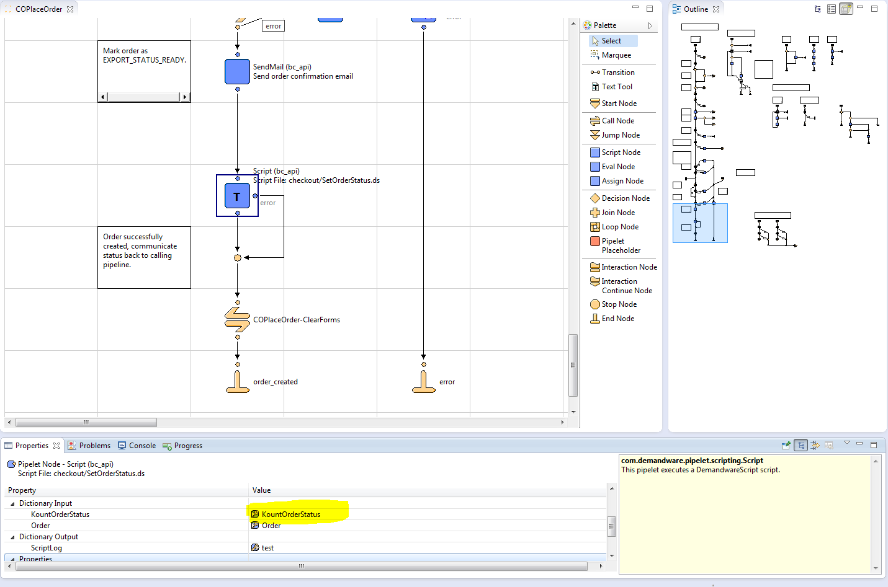

External Interfaces
The cartridge uses Event Notification System (ENS) for synchronization with the Kount.
Callback Pipelines:
For ENS we have set events and the Kount service notifies Demandware using callback. There are several callback pipelines that process the following changes:
- K_ENS- EventClassifications – determining what kind of event comes
- K_ENS- SpecialAlertTransaction, WorkflowStatusEdit, WorkflowReevaluate, RiskChangeScor, RiskChangeReply, RiskChangeVelo, RiskChangeVmax, RiskChangeGeox, RiskChangeNetw, RiskChangeReas - appropriate event handlers

Modifying UDF map
To support other Demadware objects an additional mapping should be done in method – getUDFObjectMap in script LibKount.ds
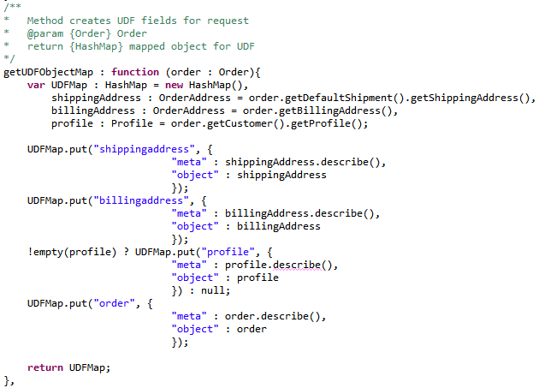
Adding new object to the map should be added in following manner:
UDFMap.put(<label of the object>, {
"meta" : <DW object>.describe(),
"object" : <DW object>
});

Appendix A: Manual Integration Steps
Create System Object Definitions (manual integration method)
1. Create the following system object definitions:
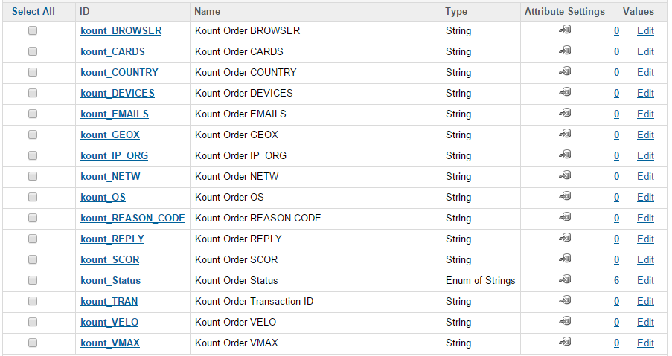
- Order
  - Kount Order Status
    - id: kount_Status
    - display name: Kount Order Status
    - type: Enum of Strings
    - mandatory: false
    - externally managed: true
    - values:
      - value: APPROVED, display value: Approved
      - value: HOLD, display value: Hold
      - value: DECLINED, display value: Declined
      - value: CHANGE, display value: Change
      - value: TIME OUT, display value: Time Out
      - value: TIME OUT PAYMENT, display value: Time Out Payment Authorization
  - Kount Order NETW
    - id: kount_NETW
    - display name: Kount Order NETW
    - type: String
    - mandatory: false
    - externally managed: true
  - Kount Order GEOX
    - id: kount_GEOX
    - display name: Kount Order GEOX
    - type: String
    - mandatory: false
    - externally managed: true
  - Kount Order SCOR
    - id: kount_SCOR
    - display name: Kount Order SCOR
    - type: String
    - mandatory: false
    - externally managed: true
  - Kount Order TRAN
    - id: kount_TRAN
    - display name: Kount Order TRAN
    - type: String
    - mandatory: false
    - externally managed: true
  - Kount Order VELO
    - id: kount_VELO
    - display name: Kount Order VELO
    - type: String
    - mandatory: false
    - externally managed: true
  - Kount Order VMAX
    - id: kount_VMAX
    - display name: Kount Order VMAX
    - type: String
    - mandatory: false
    - externally managed: true
  - Kount Order Browser
    - id: kount_BROWSER
    - display name: Kount Order BROWSER
    - type: String
    - mandatory: false
    - externally managed: true
  - Kount Order OS
    - id: kount_OS
    - display name: Kount Order OS
    - type: String
    - mandatory: false
    - externally managed: true
  - Kount Order IP_ORG
    - id: kount_IP_ORG
    - display name: Kount Order IP_ORG
    - type: String
    - mandatory: false
    - externally managed: true
  - Kount Order Cards
    - id: kount_CARDS
    - display name: Kount Order CARDS
    - type: String
    - mandatory: false
    - externally managed: true
  - Kount Order DEVICES
    - id: kount_DEVICES
    - display name: Kount Order DEVICES
    - type: String
    - mandatory: false
    - externally managed: true
  - Kount Order COUNTRY
    - id: kount_COUNTRY
    - display name: Kount Order COUNTRY
    - type: String
    - mandatory: false
    - externally managed: true
  - Kount Order EMAILS
    - id: kount_EMAILS
    - display name: Kount Order EMAILS
    - type: String
    - mandatory: false
    - externally managed: true
  - Kount Order REASON CODE
    - id: kount_REASON_CODE
    - display name: Kount Order REASON CODE
    - type: String
    - mandatory: false
    - externally managed: true

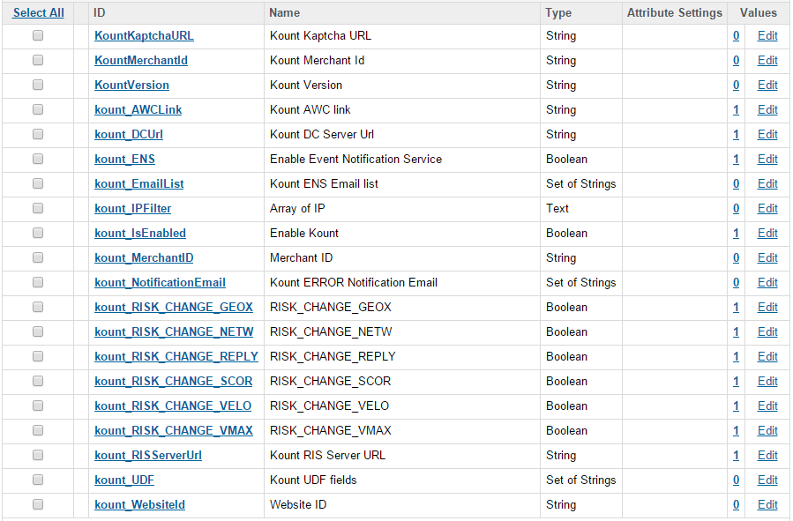
- Site Preferences
  - Enable Kount
    - id: kount_IsEnabled
    - display name: Enable Kount
    - type: Boolean
    - mandatory: false
  - Kount DC Server Url
    - id: kount_DCUrl
    - display name: Kount DC Server Url
    - description: Kount Data Collector Server Url.
    - type: String
    - mandatory: false
    - default value: https://tst.kaptcha.com
  - Kount RIS Server URL
    - id: kount_RISServerUrl
    - display name: Kount RIS Server URL
    - description: Kount RIS Server URL
    - type: String
    - mandatory: false
    - default value: https://risk.test.kount.net
  - Array of IP
    - id: kount_IPFilter
    - display name: Array of IP
    - description: Allows to skip step for particular IP address(es). E.g. 192.168.0.1, 10.10.10.1, ...
    - type: Text
    - mandatory: false
  - Website ID
    - id: kount_WebsiteId
    - display name: Website ID
    - type: String
    - mandatory: false
    - minimum value: 1
    - field length: 8
  - Merchant ID
    - id: kount_MerchantID
    - display name: Merchant ID
    - description: Merchant Number
    - type: String
    - mandatory: false
  - Kount AWC link
    - id: kount_AWCLink
    - display name: Kount AWC link
    - description: Copy and put this link to Browser, that would be go to Kount Agent Web Console
    - type: String
    - mandatory: false
    - default value: https://awc.test.kount.net
  - Enable Event Notification Service
    - id: kount_ENS
    - display name: Enable Event Notification Service
    - description: Enable/Disable ENS
    - type: Boolean
    - mandatory: false
  - Kount ENS Email list
    - id: kount_EmailList
    - display name: Kount ENS Email list
    - description: Email list for ENS
    - type: Set of String
    - mandatory: false
  - Kount ERROR Notification Email
    - id: kount_NotificationEmail
    - display name: Kount ERROR Notification Emai
    - description: In case errors entered email will be notified
    - type: Set of String
    - mandatory: false
  - RISK_CHANGE_GEOX
    - id: kount_RISK_CHANGE_GEOX
    - display name: Kount Email list
    - description: Enable/Disable notification mail
    - type: Boolean
    - mandatory: false
  - RISK_CHANGE_NETW
    - id: kount_RISK_CHANGE_NETW
    - display name: Kount Email list
    - description: Enable/Disable notification mail
    - type: Boolean
    - mandatory: false
  - RISK_CHANGE_REAS
    - id: kount_RISK_CHANGE_REAS
    - display name: Kount Email list
    - description: Enable/Disable notification mail
    - type: Boolean
    - mandatory: false
  - RISK_CHANGE_REPLY
    - id: kount_RISK_CHANGE_REPLY
    - display name: Kount Email list
    - description: Enable/Disable notification mail
    - type: Boolean
    - mandatory: false
  - RISK_CHANGE_SCOR
    - id: kount_RISK_CHANGE_SCOR
    - display name: Kount Email list
    - description: Enable/Disable notification mail
    - type: Boolean
    - mandatory: false
  - RISK_CHANGE_VELO
    - id: kount_RISK_CHANGE_VELO
    - display name: Kount Email list
    - description: Enable/Disable notification mail
    - type: Boolean
    - mandatory: false
  - RISK_CHANGE_VMAX
    - id: kount_RISK_CHANGE_VMAX
    - display name: Kount Email list
    - description: Enable/Disable notification mail
    - type: Boolean
    - mandatory: false
  - Kount UDF fields id:
    - Id: kount_UDF
    - display name: Kount UDF Fields
    - description: Kount UDF Fields
    - type: Set of String
    - mandatory: false

2. Create an attribute group for Kount site preferences and add fields.
- id: Kount
- display name: Kount
- attributes:
  - kount_IsEnabled
  - kount_DCUrl
  - kount_RISServerUrl
  - kount_IPFilter
  - kount_WebsiteId
  - kount_MerchantID
  - kount_AWCLink
  - kount_ENS
  - kount_EmailList
  - kount_RISK_CHANGE_NETW
  - kount_RISK_CHANGE_GEOX
  - kount_RISK_CHANGE_VMAX
  - kount_RISK_CHANGE_SCOR
  - kount_RISK_CHANGE_VELO
  - kount_RISK_CHANGE_REPLY
  - kount_UDF
  - kount_NotificationEmail

Appendix B: Test Cases

Verifying the Functionality of the Cartridge: Test Cases
General Prerequisites:

Requirements for Test Cases:
1. Link to send box server and Business Manager credentials.
2. Kount account (https://awc.test.kount.net)
3. In your browser installed Firebug or another tool, which help you to see page sources.

TestCase 1: BusinessManger. Kount preferences. Check required fields.
Steps:
1. Login to BM and open Kount > Site Preferences > Custom Preferences > Kount.
2. Verify that next components are available:
- Enable Kount checkbox
- Kount DC Server Url field
- Kount RIS Server URL field
- Kount AWC link field
- Array of IP textarea
- Website ID field
- Merchant ID field
- Kount ERROR Notification Email field(s)
- Kount ENS Email list field(s)
- Enable Event Notification Service checkbox
- RISK_CHANGE_NETW
- RISK_CHANGE_GEOX
- RISK_CHANGE_VMAX
- RISK_CHANGE_SCOR
- RISK_CHANGE_VELO
- RISK_CHANGE_REPLY
- Kount UDF field(s)
- Apply and Reset buttons
TestCase 2: BusinessManager. Order options. Check kount field.
Steps:
1. Login to BM and open Kount > Ordering > Orders > Find Order.
2. Open Attributes tab.
3. Verify that there is Kount Order Status select field, with next options:
- Approved
- Hold
- Declined
- Change
- Time out
- Time out payment
4. Verify that there are other fields:
- Kount Order Transaction ID
- Kount Order GEOX
- Kount Order NETW
- Kount Order SCOR
- Kount Order VELO
- Kount Order VMAX
- Kount Order BROWSER
- Kount Order OS
- Kount Order IP_ORG
- Kount Order CARDS
- Kount Order EMAILS
- Kount Order DEVICES
- Kount Order COUNTRY
- Kount Order REPLY

TestCase 3: BusinessManager. Private Keys and Certificates. Check kount keys and certificates.
Steps:
1. Login to BM and open Administration > Operations > Private Keys and Certificated.
2. Verify that Kount Private Key and 2 Trusted Certificates are available.

TestCase 4: BusinessManager Configuration. Test Mode. Check iframe.
Prerequisites:
Set Kount cartridge to Test Mode:
- Login to BM and open Kount > Site Preferences > Custom Preferences > Kount.
- Set Kount DC Server Url: https://tst.kaptcha.com
- Apply changes.

Steps:
1. Open Store Front.
2. Choose some product, add it to Cart and start Checkout as Guest.
3. On Shipping page enter a shipping address, select shipping method and click Continue button.
4. Scroll down Billing page and verify that more left than Continue button, there is a pixel (little blue rectangle).
5. Click on pixel with right button and choose in context menu - Inspect Element.
6. Verify that pixel - is a div with class = “iframe_test” and contains inside iframe component.
7. Using prompt in Prerequisites set: Set Kount DC Server Url: https://kaptcha.com
8. Open again Billing page and verify that pixel have no visualization (absent little blue rectangle).
9. Open page sources (e.g. using Firebug), search for iframe.
10. Verify that iframe component is still there and div around it is without class.

TestCase 5: Business Manager Configuration. Set self ip to Array of IP field. Didn’t send data with iframe check.
Prerequisites:
Set Kount cartridge to Test Mode:
- Login to BM and open Kount > Site Preferences > Custom Preferences > Kount.
- Set Kount DC Server Url: https://tst.kaptcha.com
- Enter your current public IP to Array of IP field (e.g. can use http://www.myipaddress.com).
- Apply changes.

Steps:
1. Open Store Front.
2. Choose some product, add it to Cart and start Checkout as Guest.
3. On Shipping page enter a shipping address, select shipping method and click Continue button.
4. Scroll down Billing page and verify that there is no pixel (little blue rectangle).
5. Open page sources(e.g. using Firebug), search for iframe.
6. Verify that there is no available iframe component on page (only disabled one, with id="_atssh", it can’t send data).
7. Select or enter a billing address, enter payment data and click Continue button.
8. Submit Order.
9. Login to Kount and open Reports > Order Search.
10. Find submitted order and open it.
11. Verify that in Current Risk Evaluation block Collector value is N and there are no device data.

TestCase 6: Business Manager Configuration. Iframe data. Check that iframe data on billing and submit order pages are the same.
Prerequisites:
Set Kount cartridge to Test Mode:
- Login to BM and open Kount > Site Preferences > Custom Preferences > Kount.
- Set Kount DC Server Url: https://tst.kaptcha.com
- Apply changes.

Steps:
1. Open Store Front.
2. Choose some product, add it to Cart and start Checkout as Guest.
3. On Shipping page enter a shipping address, select shipping method and Continue checkout.
4. Scroll down Billing page and verify that more left than Continue button, there is a pixel (little blue rectangle).
5. Click on pixel with right button and choose in context menu - Inspect Element.
6. Verify iframe component src parameter and write down it value after “s=” (e.g.s=45TaxQ66Yp5Bhn4I_EvN2pY0bc1qMiaa). All after ‘s =’ is a Session ID.
7. Select or enter a billing address, enter payment data and click Continue button.
8. Submit Order.
10. Login to Kount and open Reports > Order Search.
10. Using Start Date, find your report and click “details” link.
11. Verify that Session ID, which is in Transaction Summary is as in iframe.

Test Case 7: Send data to Kount. Check that guest user and order data sent correctly to Kount.
Steps:
1. Open Store Front.
2. Choose some product, add it to Cart and start Checkout as Guest.
3. On Shipping page enter a shipping address, select shipping method and Continue checkout.
4. Select or enter a billing address, enter payment data and click Continue button.
5. Submit Order.
6. Login to Kount and open Reports > Order Search.
7. Using Start Date, find your report and click “details” link.
8. Verify that next data sent correctly:
- Transactional Summary section: Date, Order Num
- Customer: Created, Name, Email, Ship Email, Cust. ID (empty)
- Payment: Total, Type
- Device: Location, IP Address (to find out you address can use e.g. can use http://www.myipaddress.com)
- Addresses: Billing Address, Shipping Address
- Phone Numbers: Billing Phone, Shipping Phone
- Shopping Cart
- Bank Information

TestCase 8: Send data to Kount. Check that registered user and order data sent correctly to Kount.
Steps:
1. Open Store Front.
2. Login as registered user (or register a new one).
3. Choose some product, add it to Cart and start Checkout.
4. On Shipping page enter a shipping address, select shipping method and Continue checkout.
5. Select or enter a billing address, enter payment data and click Continue button.
6. Submit Order.
7. Login to Kount and open Reports > Order Search.
8. Using Start Date, find your report and click “details” link.
9. Verify that next data sent correctly:
- Transactional Summary section: Date, Order Num
- Customer: Created, Name, Email, Ship Email, Cust. ID
- Payment: Total, Type
- Device: Location, IP Address (to find out you address can use e.g. can use http://www.myipaddress.com)
- Addresses: Billing Address, Shipping Address
- Phone Numbers: Billing Phone, Shipping Phone
- Shopping Cart
- Bank Information
TestCase 9.: Decline Order. Check that declined order return user to billing page with proper message.
Prerequisites:
Set Rules on Kount that will decline orders :
- Login to Kount
- Open Fraud Control -> Rule Sets
- Copy Rule Set and make all rules action to Declined.
- Open Rule Set and click Activate Rule Set.
So each order which come to Kount will become Declined.

Steps:
1. Open Store Front.
2. Login as registered user (or register a new one).
3. Choose some product, add it to Cart and start Checkout.
4. On Shipping page enter a shipping address, select shipping method and Continue checkout.
5. Select or enter a billing address, enter payment data and click Continue button.
6. Submit Order.
7. Verify that you redirected to billing page and “We were unable to process your transaction at this time. Please contact customer support.” notification message appeared.

TestCase 10: Workflow Reevaluate. Check that order status changed in OMS (BM), when it changed on Kount.
Prerequisites:
Need to enable ENS:
- Login to BM and open Kount > Site Preferences > Custom Preferences > Kount.
- Check Enable Event Notification Service checkbox.
- Apply changes.

Steps:
1. Open Store Front.
2. Login as registered user (or register a new one).
3. Choose some product, add it to Cart and start Checkout.
4. On Shipping page enter a shipping address, select shipping method and Continue checkout.
5. Select or enter a billing address, enter payment data and click Continue button.
6. Submit Order.
7. Login to Kount and open Reports > Order Search.
8. Using Start Date, find your report and click “details” link.
9. Verify order status and Transaction ID.
10. Login to BM and open Kount > Ordering > Orders > Find and open your order.
11. Open Attributes tab and verify that order status, Transaction ID have the same values as on Kount.
12. Again open order on Kount and change it status using form in the bottom of page.
13. Open order in BM and verify that order status changed.

TestCase 11: Risk Change Score. Check that order risk evaluation changed OMS (BM), when it changed on Kount.
Prerequisites:
Need to enable ENS:
- Login to BM and open Kount > Site Preferences > Custom Preferences > Kount.
- Check Enable Event Notification Service checkbox.
- Apply changes.

Steps:
1. Open Store Front.
2. Login as registered user (or register a new one).
3. Choose some product, add it to Cart and start Checkout.
4. On Shipping page enter a shipping address, select shipping method and Continue checkout.
5. Select or enter a billing address, enter payment data and click Continue button.
6. Submit Order.
7. Login to Kount and open Reports > Order Search
8. Using Start Date, find your report
9. Click “details” link.
10. Verify data in Current Risk Evaluation block.
11. Login to BM and open Kount > Ordering > Orders > Find and open your order.
12. Open Attributes tab and verify that order status, Transaction ID have the same values as on Kount.
13. Make the XML posts for the RISK EVENT changes and the Reevaluate change events.
14. Open order in BM and verify that order RISK EVENT attribute changed.

TestCase 12. Plain Text Error handler verification
1. Login to BM and open Administration > Operations > Private Keys and Certificated
2. Change certificate to wrong one to emulate the situation, when Kount Certificate is expired. Certificate should already expired for Kount or from different Kount account
3 Open Store Front.
2. Choose some product, add it to Cart and start Checkout.
3. On Shipping page enter a shipping address, select shipping method and Continue checkout.
4. Select or enter a billing address, enter payment data and click Continue button.
5. Submit Order.
6. Login to BM and open Administration > Site Development > Development Setup > Open Logs folder
7. Verify appropriate record availability - custom - <kount> - <hostname> - appserver - <creation date of the file in GMT>.log
8. Login to BM and find placed order via number.
9. Verify that order is correctly processed in DW and order data is not passed to Kount.

TestCase 13. Additional Payment Types verification
1. Open Store Front.
2. Choose some product, add it to Cart and start Checkout as Guest.
3. On Shipping page enter a shipping address, select shipping method and Continue checkout.
4. Select or enter a billing address, enter different payment method, fill correct data (important for PayPal) and click Continue button.
5. Submit Order.
6. Login to Kount and open Reports > Order Search.
7. Using Start Date, find your report and click “details” link.
8. Verify that next data sent correctly:
- In case PayPal used – on Kount should be PayPal
- In case Credit Card + Pay Pal used – on Kount should be Credit Card
- In case Gift card used – on Kount should be Gift card
- In case Gift card + Credit Card used – on Kount should be Credit Card
- In case Gift card + Pay Pal used – on Kount should be PayPal

TestCase 14. User Defined Fields verification
1. Login to BM and open Kount > Site Preferences > Custom Preferences > Kount
2. Setup UDF fields in Demandware instance. Fill 'Kount UDF fields' field with 3 values:
- for Order DW object (e.g. TESTUDF1|order.Order Attribute Definition ID)
- for OrderAddress DW object (e.g. TESTUDF2|shippingaddress.OrderAddress Attribute Definition ID)
- for Profile DW object (e.g. TESTUDF3|profile.Profile Attribute Definition ID)
3. In Kount admin set 3 UDF fields (same as for #2)
4. Open Store Front.
5. Choose some product, add it to Cart and start Checkout.
6. On Shipping page enter a shipping address, select shipping method and Continue checkout.
7. Select or enter a billing address, enter payment data and click Continue button.
8. Submit Order.
9. In Kount admin verify UDF fields values for placed order.
10. Login to BM and open Kount > Site Preferences > Custom Preferences > Kount
11. Change UDF to have not correct values.
- for Order DW object (e.g. TESTUDF1|xxx.Order Attribute Definition ID)
12. Open Store Front.
13. Choose some product, add it to Cart and start Checkout.
14. On Shipping page enter a shipping address, select shipping method and Continue checkout.
15. Select or enter a billing address, enter payment data and click Continue button.
16. Submit Order.
17 Data for incorrect UDF is not sent to Kount.
18. Error is occured, Log file contains appropriate info about error in custom - <kount> - <hostname> - appserver - <creation date of the file in GMT>.log
19. Login to BM and open Kount > Site Preferences > Custom Preferences > Kount
20. Change UDF to have correct values.
- for Order DW object (e.g. TESTUDF1|order.Order Attribute Definition ID)
21. In Kount admin panel delete TESTUDF1.
22. Open Store Front.
23. Choose some product, add it to Cart and start Checkout.
24. On Shipping page enter a shipping address, select shipping method and Continue checkout.
25. Select or enter a billing address, enter payment data and click Continue button.
26. Submit Order.
27. Data for TESTUDF1 is not sent to Kount.
28. Error is occured, Log file contains appropriate info about error in custom - <kount> - <hostname> - appserver - <creation date of the file in GMT>.log

TestCase 15. Errors logging and email notification verification
1. Login to BM and open Kount > Site Preferences > Custom Preferences > Kount
2. Fill 'Kount Notification Email' field with 2 e-mails.
3. Сreate a test situation when Kount service is unavailable
- Incorrect certificate.
- Wrong UDF field value.
4. Open Store Front.
5. Choose some product, add it to Cart and start Checkout.
6. On Shipping page enter a shipping address, select shipping method and Continue checkout.
7. Select or enter a billing address, enter payment data and click Continue button.
8. Submit Order.
9. Login to BM and open Administration > Site Development > Development Setup > Open Logs folder
10. Verify separate log file availability: custom - <kount> - <hostname> - appserver - <creation date of the file in GMT>.log
11. Verify log file content has following format: [error time in GMT] <error type> <system description> <custom description>
12. Go to mail boxes .
13. Verify e-mail availability for each e-mail box. Recipient data will contain the following:
from - noreply@noreply.com
to - value from site preferences
cc - empty
bcc - empty

TestCase 16: Risk Change Score. Check that email with old and new Evaluation data receiving, when Risk and Reevaluation events changed.
Prerequisites:
Need to enable ENS:
- Login to BM and open Kount > Site Preferences > Custom Preferences > Kount.
- Check Enable Event Notification Service checkbox.
- Add your email to Kount Email list
- Check checkbox for all RISK_CHANGE parameters
- Apply changes.

Steps:
1. Open Store Front.
2. Login as registered user (or register a new one).
3. Choose some product, add it to Cart and start Checkout.
4. On Shipping page enter a shipping address, select shipping method and Continue checkout.
5. Select or enter a billing address, enter payment data and click Continue button.
6. Submit Order.
7. Login to Kount and open Reports > Order Search
8. Using Start Date, find your report
9. Click “details” link.
10. Verify data in Current Risk Evaluation block.
11. Login to BM and open Kount > Ordering > Orders > Find and open your order.
12. Make the XML posts for the RISK EVENT changes and the Reevaluate change events.
13. Open your email box.
14. Verify availability of e-mail with old and new Risk Evaluation data.

Appendix C: Demandware Order Workflow
This appendix contains examples of the workflow within a default installation of the Kount Link Cartridge & the expected workflow diagram.

Kount Review/Escalate
This is an example of an order that has triggered a Review or Escalate rule action in Kount.
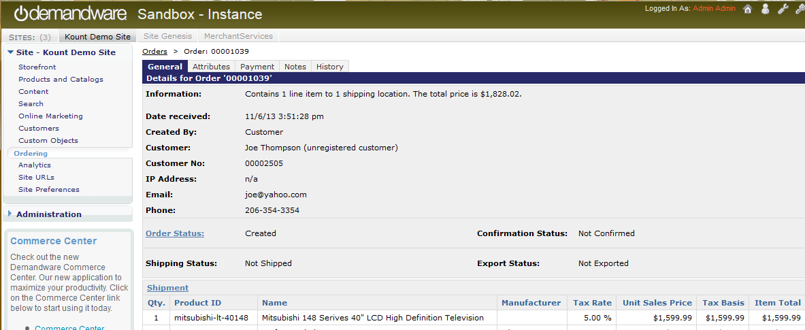
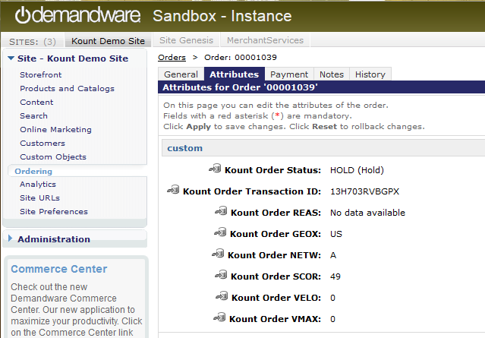

Kount Approved
This is an example of an order that has not triggered a rule or was manually Approved in Kount.
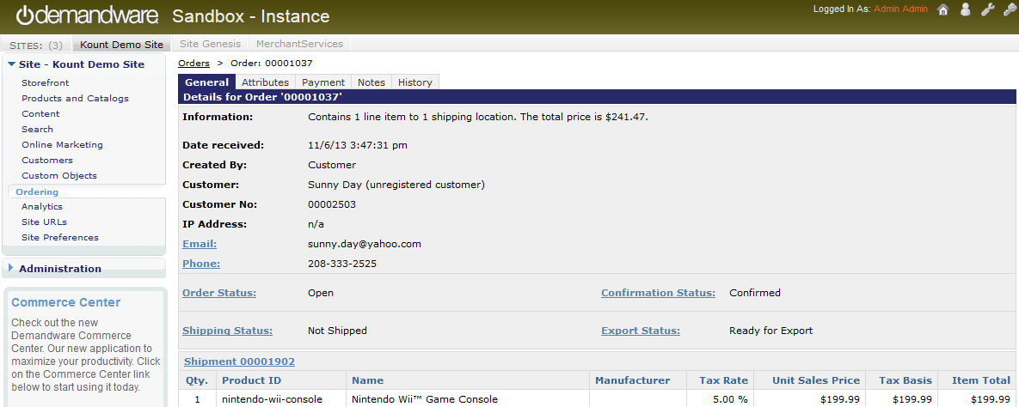
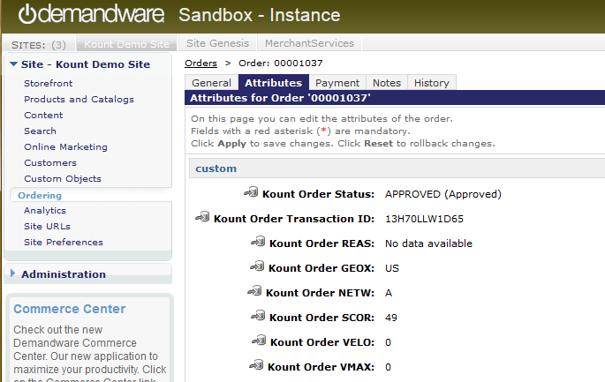

Kount Decline
This is an example of an order that triggered a Decline rule action or was manually Declined in Kount.
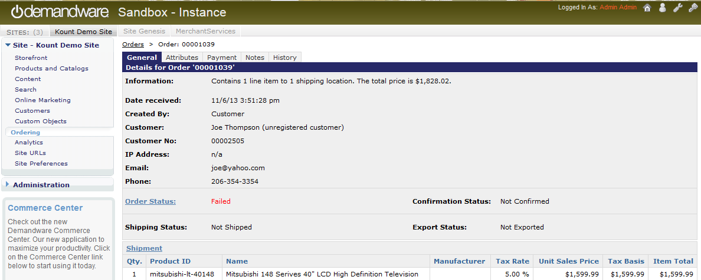
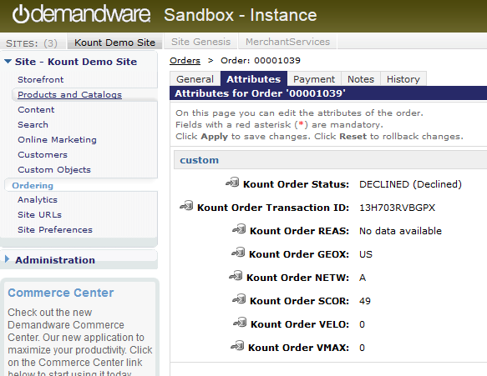

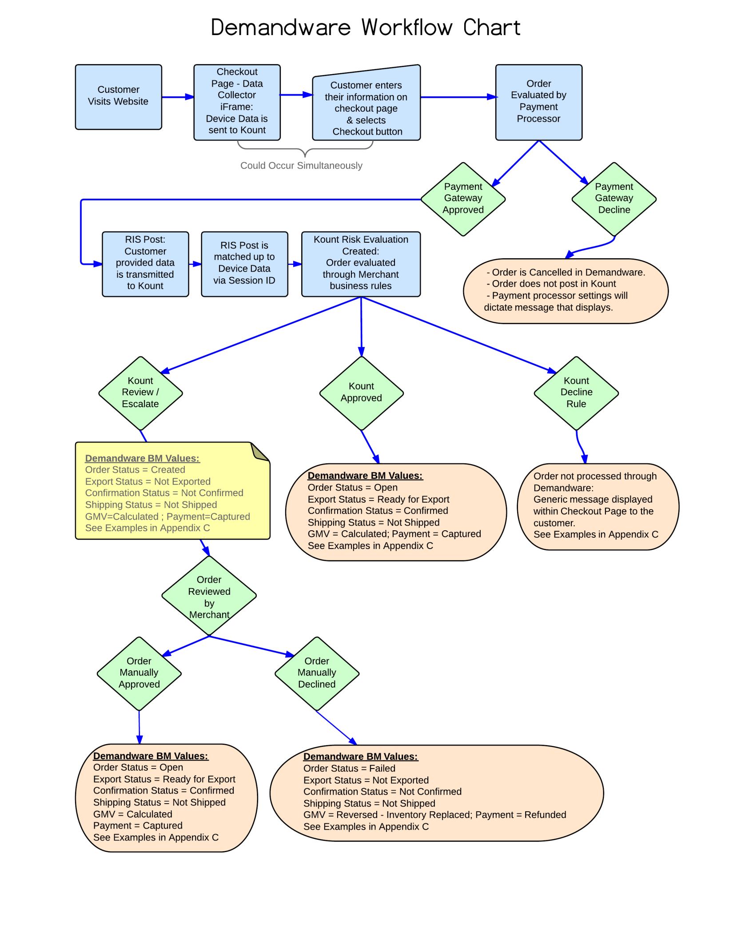

Appendix C: Certificate Exportation
To preserve the security of RIS data, merchants must authenticate to RIS using an X.509 certificate when submitting RIS requests. Certificates are exported via a browser. Additional details regarding the certificate are found in the SDK Guide.
Supported Browsers for certificate exportation:
 Microsoft Internet Explorer version 7 and newer (must be in compatibility mode for IE 10).
 Mozilla Firefox version 5 and newer
 Apple Safari

NOTE: Google Chrome does not support the exportation of certificates.

Firefox

Certificate Request:
Requesting a Certificate using Mozilla Firefox

- From https://awc.kount.net/login.html, select the ADMIN tab, RIS Certificates.

- Choose the Request RIS Certificate button at the bottom right of the RIS Certificate page.

- The Request RIS Certificate dialog will display. Enter a unique name and select the Request Certificate button.
- The Alert pop-up will display. Select the OK button. (Close the Request RIS Certificate dialog box, (it remains open by default).

Certificate Export:

- From the Firefox web browser toolbar, Select Options, Options.

- The Options dialog will display, select the Advanced icon. Choose the Encryption tab, and View Certificates button.

- The Certificate Manager dialog will display. Select the certificate created earlier from the Your Certificates tab. Select the Backup button.

- The File Name to Backup dialog will display. Select a location to save the certificate file. Enter a unique name. The default file format is PKCS12 Files (*.p12). Select the Save button.

- The Choose a Certificate Backup Password dialog will display. Enter a password for the certificate backup in the Certificate backup password field, enter the same password again in the Certificate backup password (again) field, and select the OK button.

- The Alert dialog indicating that the certificate and private key have been successfully backed up will display. Select the OK button.

IE 9

Prerequisites
Configure Internet Explorer settings and add sites to Trusted sites.
- Click Tools and then click Internet Options. Click Security tab and then click Custom level button.
- In the Settings box, scroll down and locate Initialize and script ActiveX controls not marked as safe for scripting (not secure) and click Prompt, then click OK.

- On the Security tab in Internet Options, select Trusted Sites, and then click Sites.

- In the Trusted Sites dialog, in the Add this website to the zone field, type in the URL of the website such as in https://awc.test.kount.net and https://awc.kount.net and click Add. The URL will be added to the Websites field. Click Close.

- On the Internet Options dialog, click OK.

- You must restart Internet Explorer to allow your changes to be applied.

Certificate Request:
- From https://awc.kount.net/login.html, select the ADMIN tab, RIS Certificates.
- Choose the Request RIS Certificate button at the bottom right of the RIS Certificate page.

- The Request RIS Certificate dialog will display. Enter a unique name and select the Request Certificate button.
- The Alert pop-up will display. Select the OK button. (Close the Request RIS Certificate dialog box, (it remains open by default).

Certificate Export:
1. In IE click Tools, Internet Options, Content tab, Certificates button.

2. On the Certificates window, on the Personal tab, click the name of the certificate in the list you wish to export and then click the Export button.

3. Click Next on the Certificate Export Wizard window.

4. Click Yes, export the private key radio button

5. On the Export File Format page, select the Personal Information Exchange radio button, any of the check boxes beneath the radio button that suits your security needs, and click Next.

NOTE – While it is entirely up to the merchant as to which, if any, of these options is selected. To be PCI Standards compliant, it is recommended that the Delete the private key if the export is successful check box is checked. This prevents any unauthorized person who may gain access to a merchant environment from exporting your private key to a remote location for malicious purposes. However, if you select this option and later require access to it, you will need to request a new RIS certificate from Kount. Page | 60

6. On the Password page, enter the password for the certificate you are exporting in the Password field (must be at least six characters), enter it again in the Type and confirm password (mandatory) field, and then click Next.

7. Input path or Browse to location where you would like to save the exported file.

8. In the Completing the Certificate Export Wizard page click Finish.

9. A successful notification should appear.

